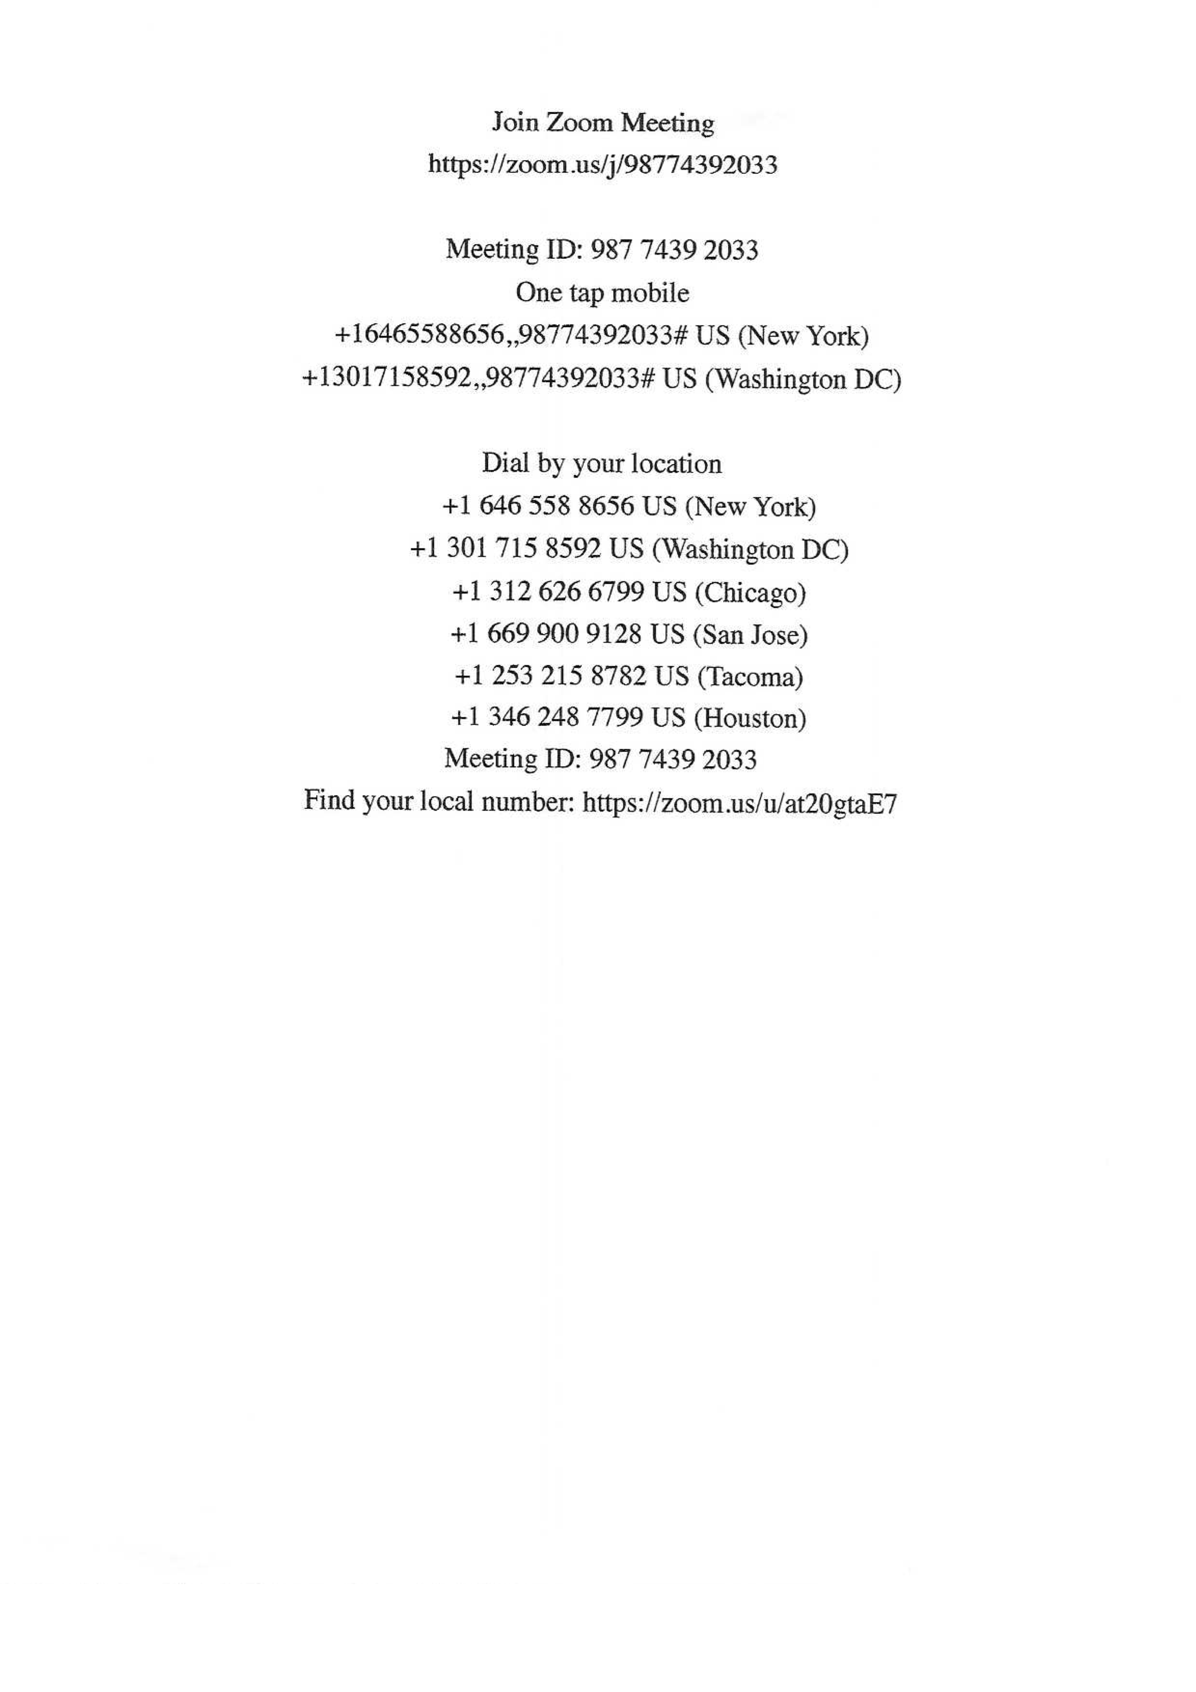
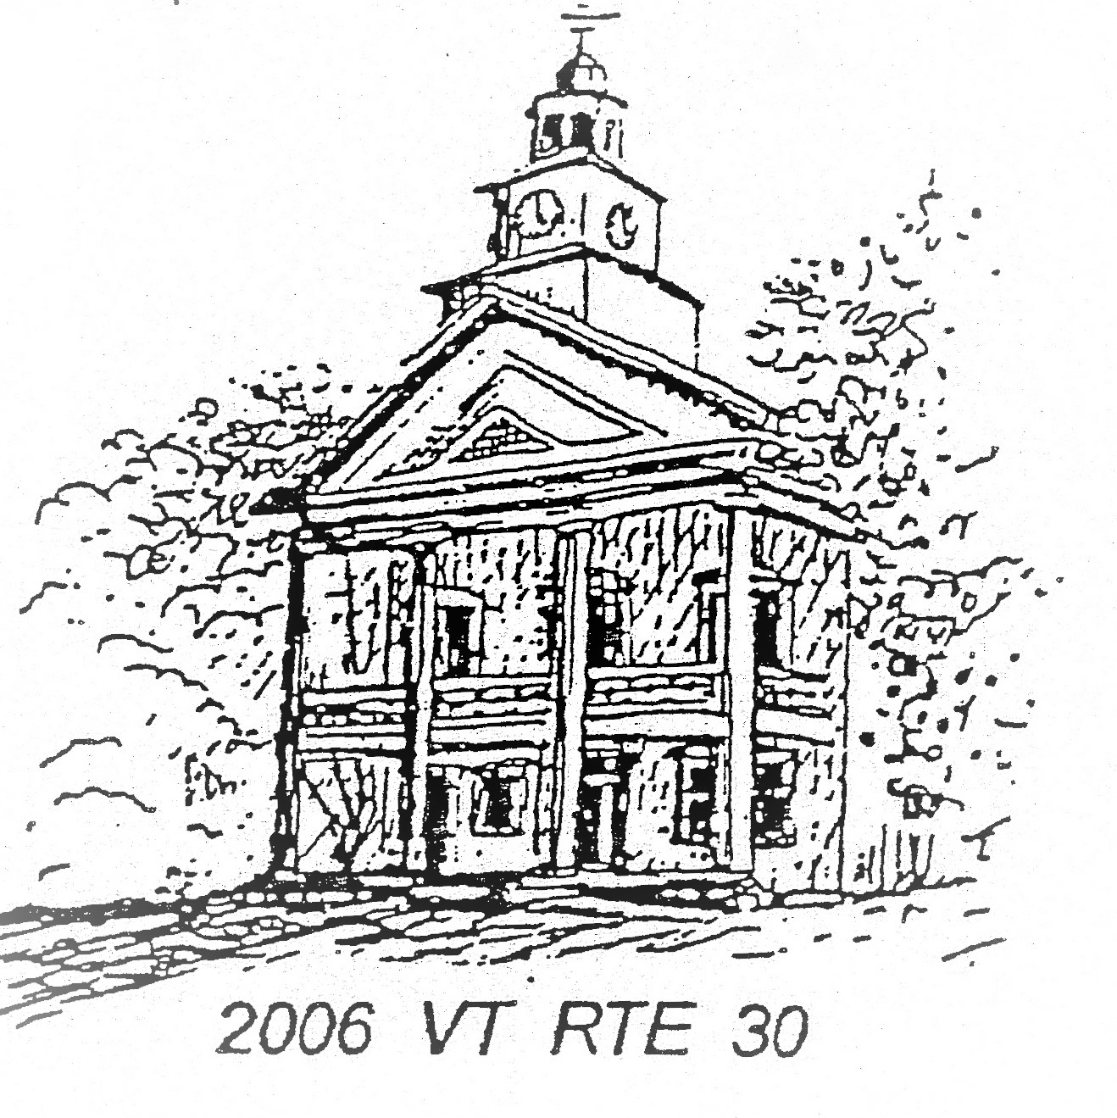
TOWN OF TOWNSHEND
Selectboard
PO Box 223 Townshend, Vermont 05353

SELECTBOARD MEETING AGENDA
February 10, 2026 6:00 PM
Townshend Town Hall
And ZOOM Virtual Meeting if possible

- Meeting Call to Order: Reading of Meeting Decorum
- Approval of Minutes: Approval of the January 27, 2026 meeting minutes.
- Additions and Deletions:
- Members of the Public:
- Correspondence:
- Warrants:
- Reports:
  - Highway
  - Treasurer
  - Town Clerk
  - Chair: Budget status report update
  - Grant Coordinator: 2nd meeting of the month
- Old Business:
  - NEMRC contract for reappraisal
  - State Animal Control form
  - Treasurer Transition Plan
- New Business:
  - Pre-Town Meeting information Meeting: set day and time.
  - GMP request to move telephone pole in front of Library
  - Leland & Gray Town Hall use request: VT Regional Drama Festival
  - Allie Dercoli Common use request: Pickle Festival
  - Friends Of Town Hall - Town Hall Use request: A Beautiful Life historical presentation
  - Cory Ciklin: request to launch town website at Town Meeting
- Executive Session: per VT State statue 1 V.S.A 313(1e)
- Next Regularly Scheduled Meeting: February 24, 2026 at 6pm
- ZOOM Link

TOWNSHEND SELECT BOARD MEETING ZOOM LINK

Join Zoom Meeting
https://zoom.us/j/5035415920?pwd=zJfJNQ9Wb1V2Q5FO5wdJXEMggtSp9H.1&omn=98784444997

Meeting ID: 503 541 5920
Passcode: 306015

One tap mobile
+13092053325,,5035415920#,,,,*306015# US
+13126266799,,5035415920#,,,,*306015# US (Chicago)

Dial by your location:
• +1 929 205 6099 US (New York)
• +1 312 626 6799 US (Chicago)

Meeting ID: 503 541 5920
Passcode: 306015

Find your local number: https://zoom.us/u/abojvtGIpy

