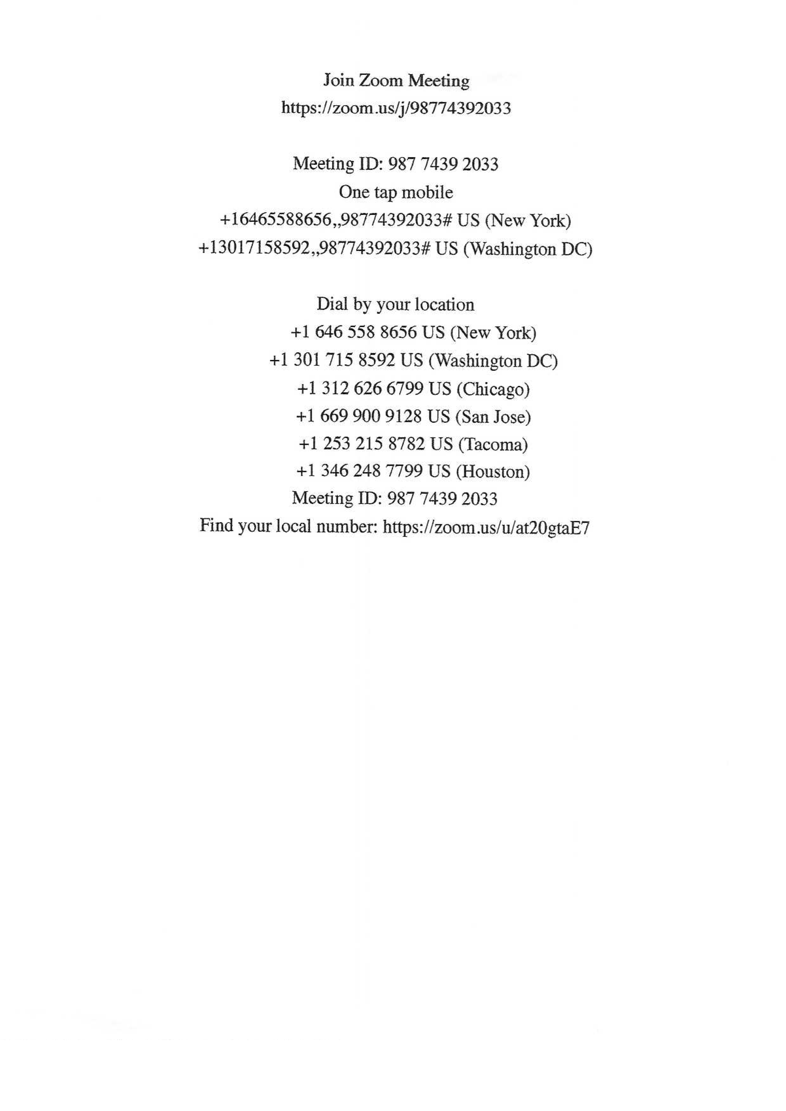
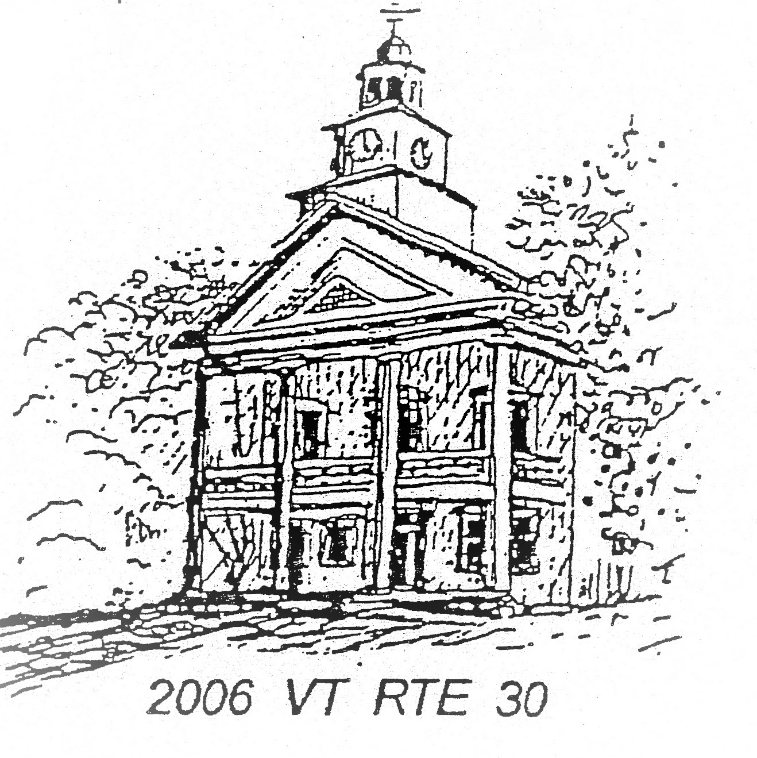
TOWN OF TOWNSHEND
Selectboard
PO Box 223 Townshend, Vermont 05353

SELECTBOARD MEETING AGENDA
February 24, 2024 6:00 PM
Townshend Town Hall
And ZOOM Virtual Meeting if possible

- Meeting Call to Order: Chair reads meeting decorum
- Approval of Minutes: Approval of the February 10, 2026 meeting minutes and the Special Selectboard meeting minutes of February 19, 2026.
- Additions and Deletions:
- Members of the Public:
- Correspondence:
- Warrants:
- Reports:
  - Highway
  - Treasurer
  - Town Clerk
  - Chair
  - Grant Coordinator
- Old Business:
- New Business:
  - VTrans Certificate of Highway Mileage
  - VTrans Certificate of Compliance for Town Roads & Bridges
  - Liquor License approval: Harmonyville Store
  - Town Hall use request: Fire Department – 3/11/26
  - Town Hall use request: Townshend Historical Society – 5/21/26
- Executive Session: per VT Statue 1 V.S.A ξ313(1.b) and ξ313(1.e)
- Next Regularly Scheduled Meeting:
- ZOOM Link

TOWNSHEND SELECT BOARD MEETING ZOOM LINK

Join Zoom Meeting
https://zoom.us/j/5035415920?pwd=zJfJNQ9Wb1V2Q5FO5wdJXEMggtSp9H.1&omn=98784444997

Meeting ID: 503 541 5920
Passcode: 306015

One tap mobile
+13092053325,,5035415920#,,,,*306015# US
+13126266799,,5035415920#,,,,*306015# US (Chicago)

Dial by your location:
• +1 929 205 6099 US (New York)
• +1 312 626 6799 US (Chicago)

Meeting ID: 503 541 5920
Passcode: 306015

Find your local number: https://zoom.us/u/abojvtGIpy

