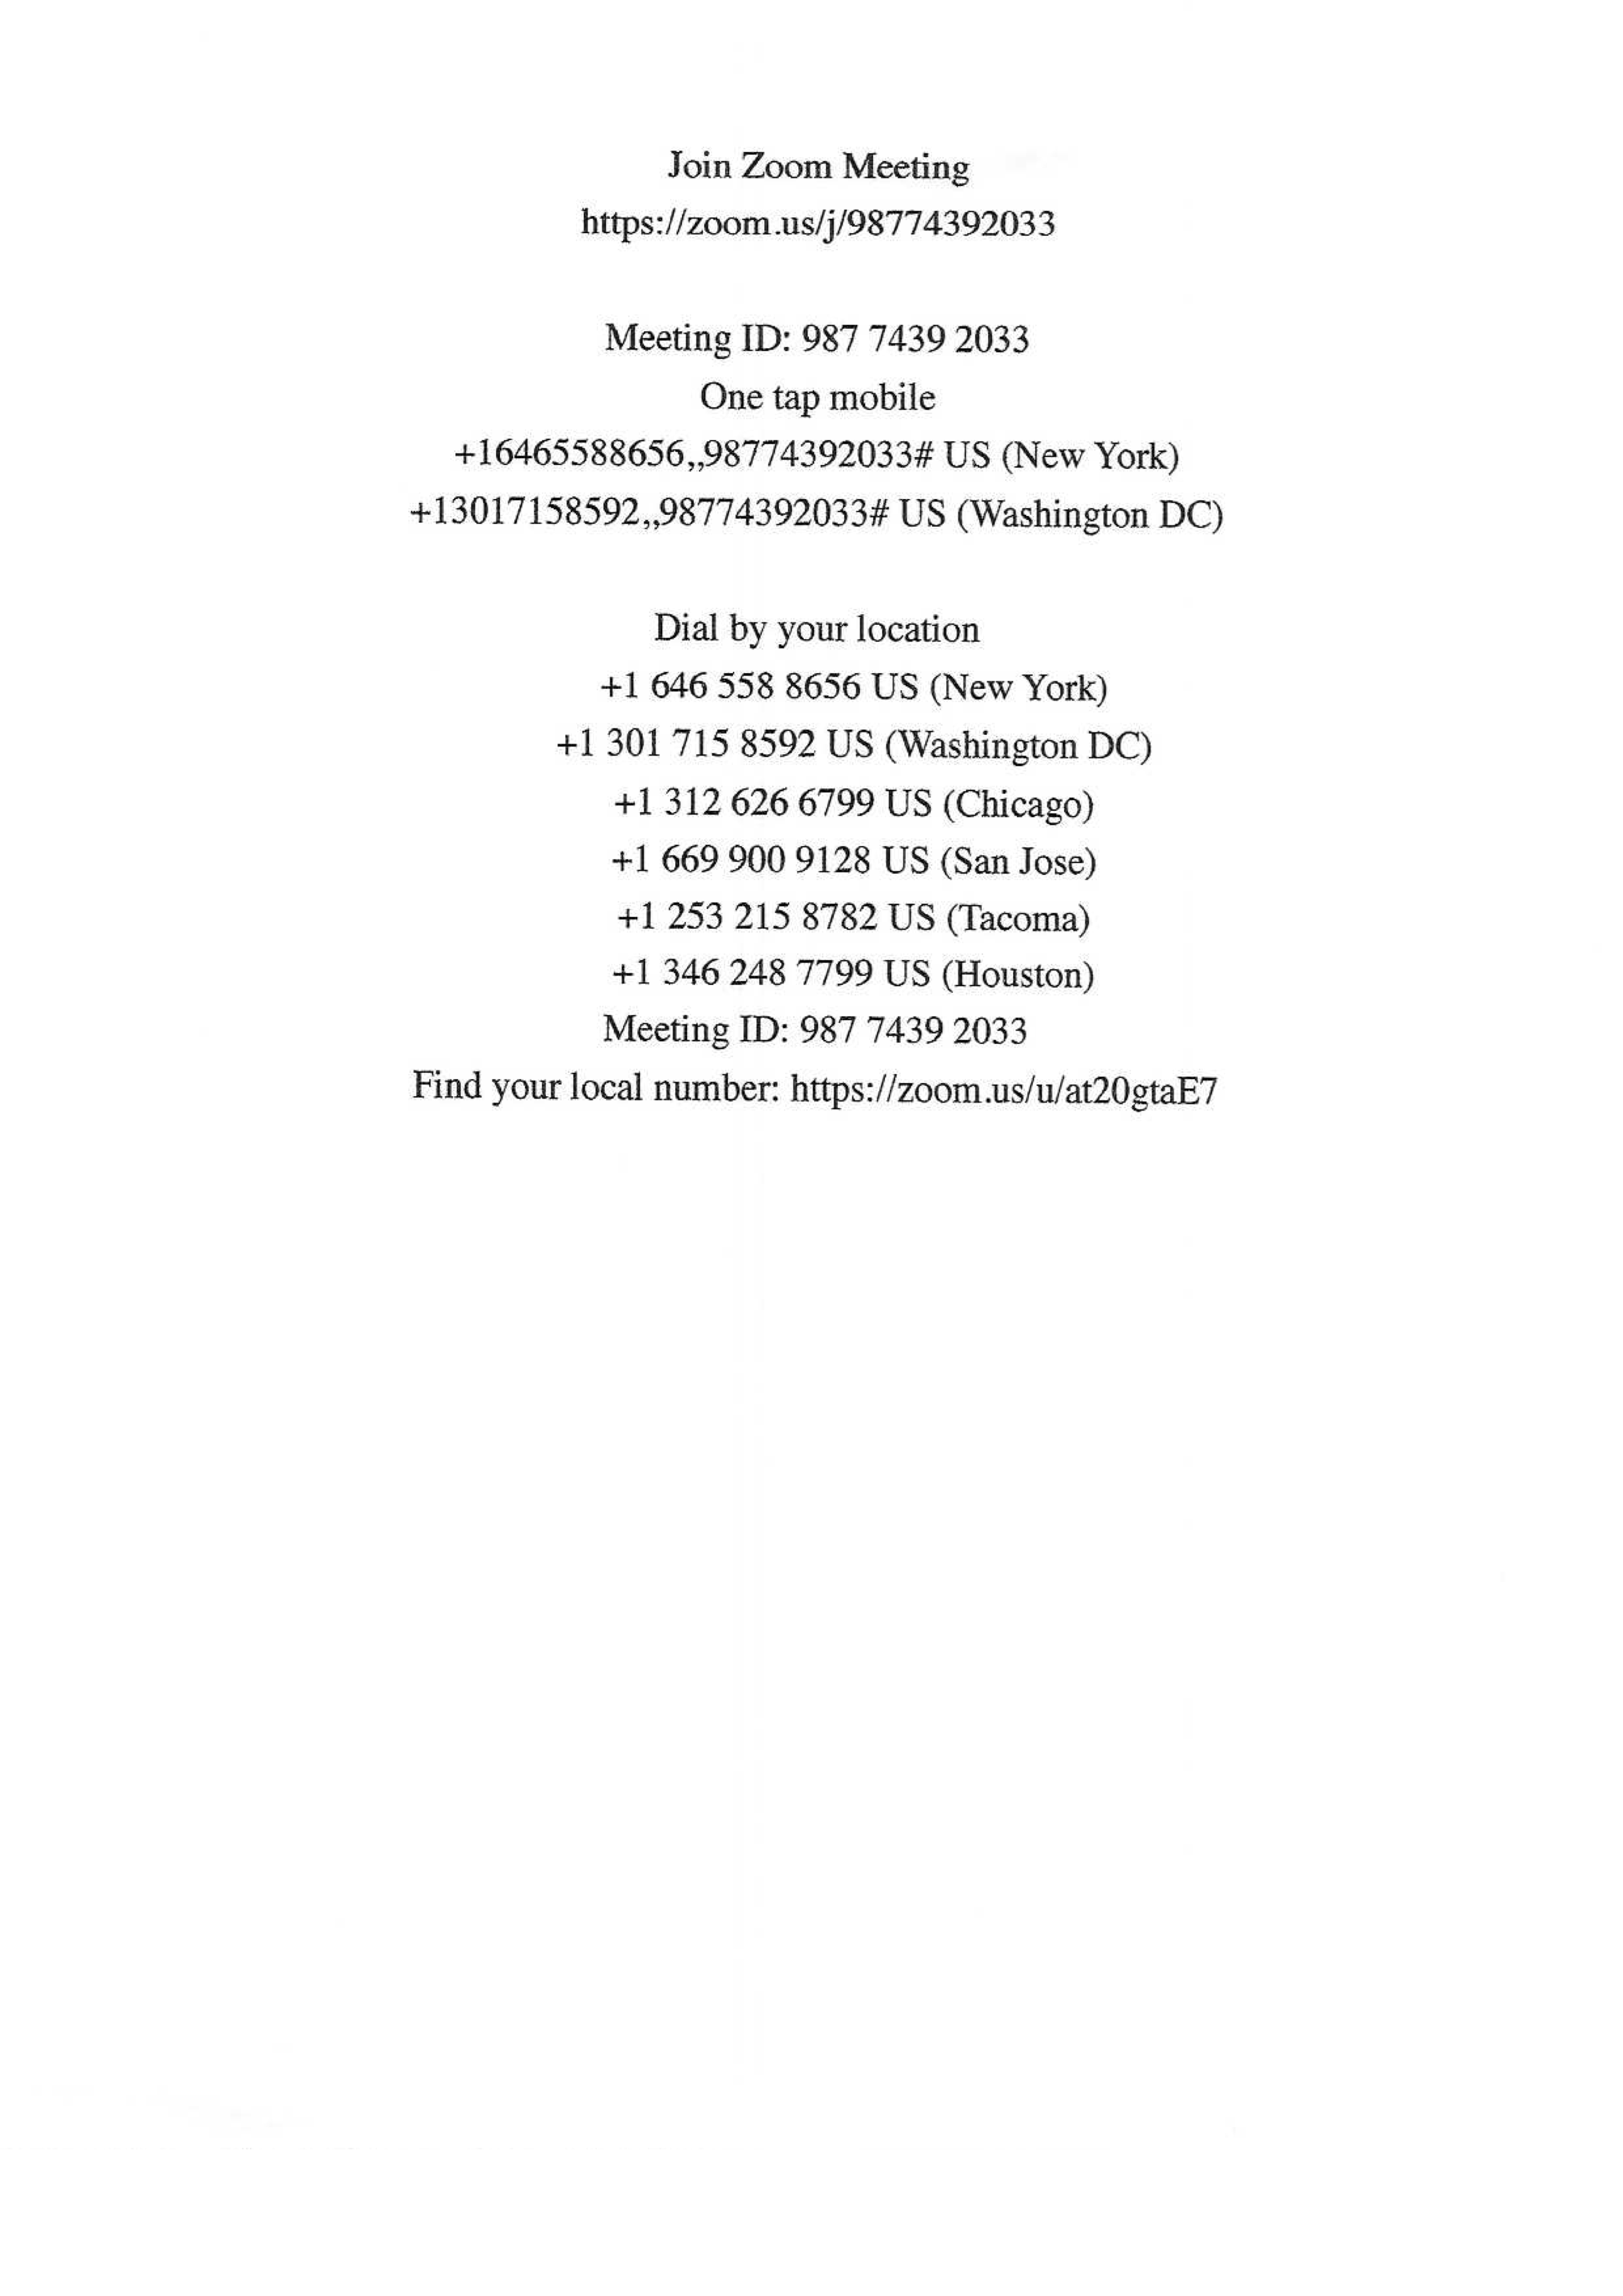
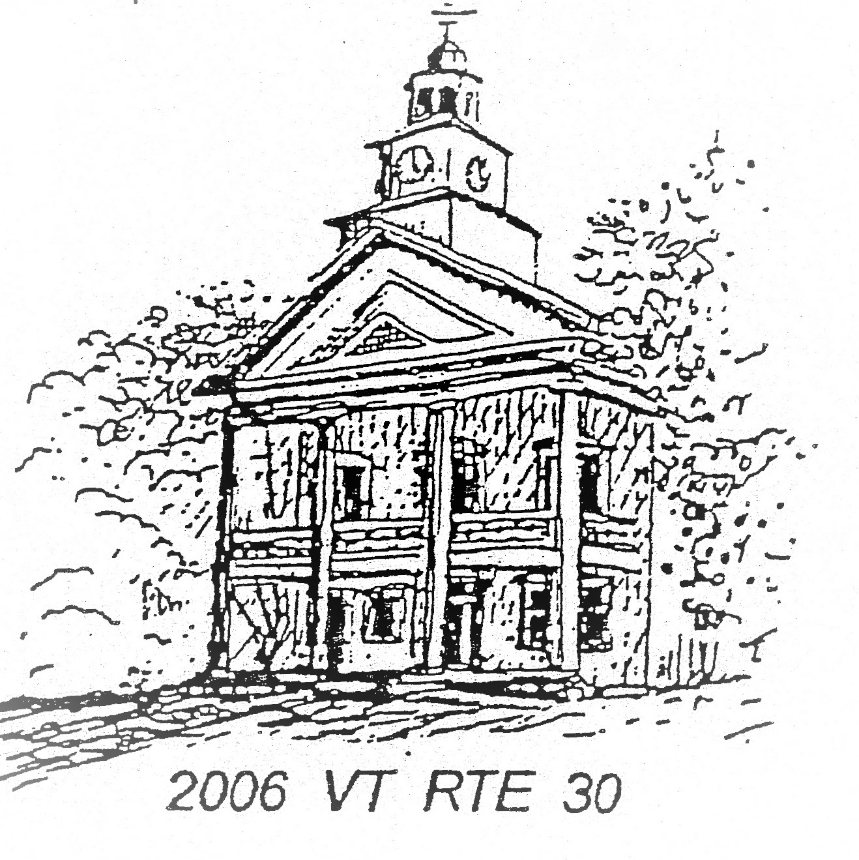
TOWN OF TOWNSHEND
Selectboard
PO Box 223 Townshend, Vermont 05353

SELECTBOARD MEETING AGENDA
February 24, 2025 6:00 PM
Townshend Town Hall
Approved: 3/10/26

Present: Allie Evans, Nick Suarez, Steve Frisk, Katie Marrow
In Attendance: Jeremy Zumbruski, Connie Holt, Brian Guerrino - BCTV
Members of the Public: Irv Stowell, Scott Dorman, Laura Richardson, Bob DeSiervo, Charles Marchant, Rick Matschke, Pam Corbett

- Meeting Call to Order: Evans calls the meeting to order at 6:00pm and reads meeting decorum.
- Approval of Minutes: Suarez makes a motion to approve the February 10, 2026 meeting minutes. Frisk seconds the motion. Motion carries 5-0-0. Suarez makes a motion to approve the Special Selectboard meeting minutes of February 19, 2026. Wright seconds the motion. Motion carries 4-0-1.
- Additions and Deletions: none
- Members of the Public: Bob DeSiervo, resident, reads a statement. The meeting is paused due to disruption. DeSiervo submits his statement to the Board.
- Correspondence: none
- Warrants: Wright makes a motion to pay warrants 1-7.
Payroll: $14,947.04
Payroll Taxes $7,168.18
General Fund $470.06
General Fund $11,895.08
Highway $9,100.84
Library $3,310.84
Total: 46,891.85
Frisk seconds the motion. Suarez makes a motion to amend the motion to hold off paying the Library warrant in order to confer with the Library Trustees. The revised warrants total would be $43,581.01. Frisk seconds the motion to amend. The motion to amend carries 4-0-1. Vote on revised warrants. Motion carries 4-0-1.
- Reports:
  - Highway: Zumbruski reports that he has procured salt.
  - Treasurer: Evans reports that the Treasurer reports that there is $1,000,547.11 in the municipal investment fund and $30,000 in the checking account.
  - Town Clerk: Evans gives the Clerk report. She reports that in the first two weeks of February the Clerk took in $1,512.00 in fees and services.
  - Chair: Evans announces that the Town Website is up and running.
  - Grant Coordinator:
    - Awarded Grants: VTrans Bridge 43 repair, VTrans Bridge 41 engineering study, VTrans streambank repair, VTrans road ditching/culvert, safety signage.
    - Outstanding grant applications: VTrans culvert #9 replacement Athens Rd, East Hill Rd culvert #42 Scoping Study, hazardous tree removal grant, HSIP guardrail replacement grant.
    - Applications in Progress: AARP, VLCT PACIF, VT Historic Preservation for windows at Town Hall, USDA grant
    - UVM Capstone project for the sidewalk study: Marrow met with them and the report should be out in May.
    - VTrans Grants: Meeting with Meghan Brunk in early March to discuss grants opportunities.
- Old Business: None
- New Business:
  - VTrans Certificate of Highway Mileage: Suarez makes a motion to sign the VTrans Certificate of Mileage. Frisk seconds the motion. Motion carries 5-0-0.
  - VTrans Certificate of Compliance for Town Roads & Bridges: Marrow makes a motion sign the VTrans certificate of compliance of bridges & roads. Suarez seconds the motion. Motion carries 5-0-0.
  - VTrans Roads & Bridge Standards: Wright makes a motion to sign the VTrans Roads and Bridge Standards. Suarez seconds the motion. Motion carries 5-0-0.
  - Liquor License approval: Wright makes a motion to approve the Harmonyville Store Liquor License. Suarez seconds the motion. Motion carries 4-0-1.
  - Town Hall use request: Suarez makes a motion to approve the Fire Department use request for 3/11/26, waive the fee, and authorize Allie to sign on behalf of the Board. Wright seconds the motion. Motion carries 5-0-0.
  - Town Hall use request: Suarez makes a motion to approve the Townshend Historical Society use request for 5/21/26, to waive the fee, and to authorize Allie to sign on behalf of the Board. Wright seconds the motion. Motion carries 4-0-1.
- Executive Session: Suarez makes a motion to enter into executive session per VT Statue 1 V.S.A ξ313(1.b) and ξ313(1.e) regarding a personnel and legal matter. Wright seconds the motion. Motion carries 5-0-0. The Selectboard move into executive session at 6:27pm.
Suarez makes a motion to exit executive session and re-enter into the regular meeting. Frisk seconds the motion. Motion carries 5-0-0. The regular meeting is reconvened at 7:28pm.
Wright makes a motion to get ahold of the town lawyer and report back. Suarez seconds the motion. Motion carries 5-0-0.
- Adjournment: Suarez makes a motion to adjourn. Marrow seconds the motion. Motion carries 5-0-0. Meeting is adjourned at 7:28pm.

- Next Regularly Scheduled Meeting: to be determined

